C source code -bool checkPerfectNumber(int num) {
if (num <= 1) return false;

int sum = 1; // Start with 1 since 1 is always a proper divisor

for (int i = 2; i * i <= num; i++) {
if (num % i == 0) {
sum += i;
if (i * i != num) {
sum += num / i; // Add the complementary divisor
}
}
}

return sum == num;
}
Screenshot - 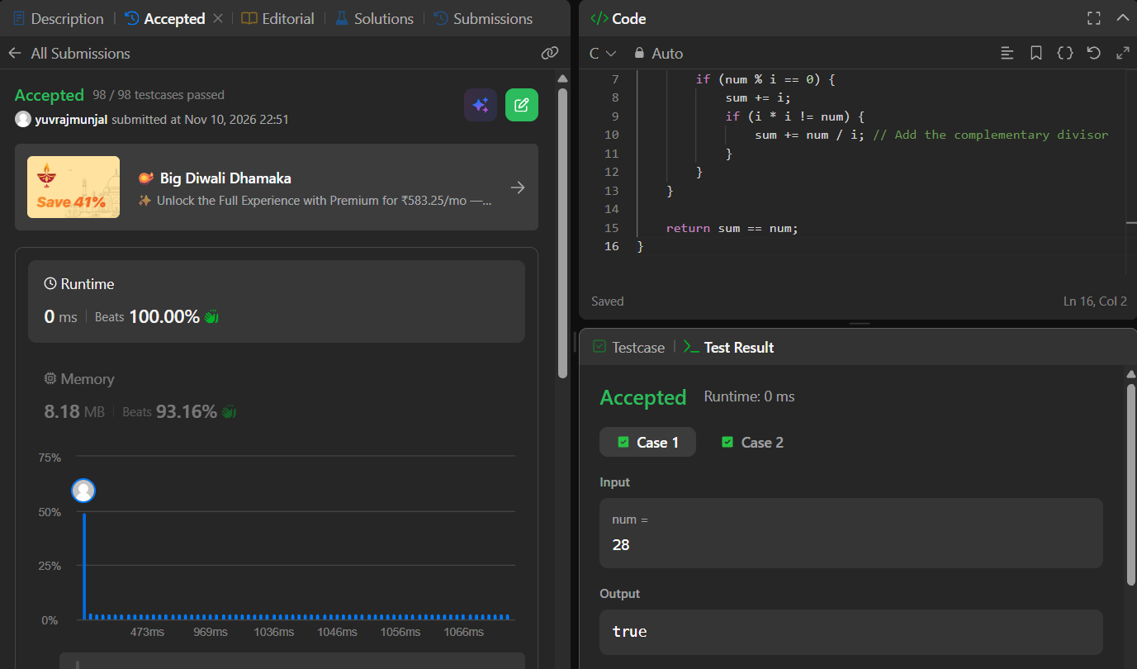

Problem link - https://leetcode.com/problems/perfect-number/

